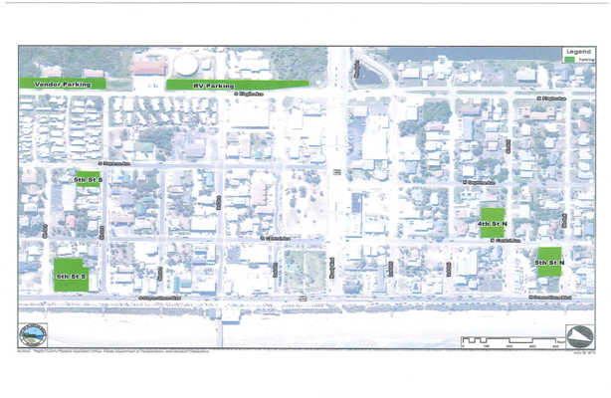
City Vehicular Parking Lot Locations

North SR 100 South SR 100
N. 4th Street / N. Central Avenue 311 N. Central Avenue S. 5th Street / S. Ocean Shore Blvd 504 S. Ocean Shore Blvd.
N. 5th Street / N. Central Avenue 109 N. 5th Street S. 5th Street / S. Daytona Ave. 503 S. Daytona Ave.
S. 8th Street / S. Central 113 S. 8th Street

